Comparative Phenotype Networks Project Analysis Journal

2/11/16

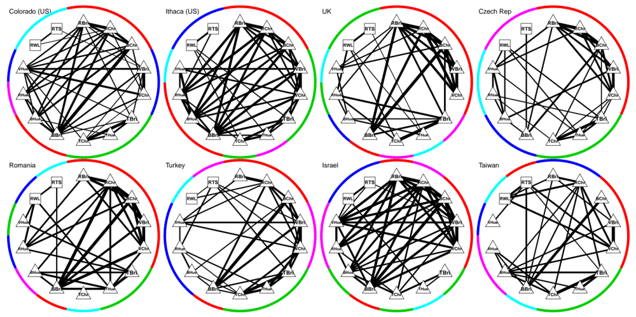
Fig 1. 8 Male barn swallow population phenotype networks, arranged West to East. Edges filtered by PCIT. Colors are PCs: PC1=red; PC2=green; PC3=dark blue; PC4=light blue; PC5=pink. Arrangement of nodes is based on Czech Republic populations (nominate subspecies). Just eyeballing, it looks like pops w/ selection for dark color have much denser network w/r to color. Really interesting that the one population where there’s strong, significant selection for streamers, there’s no relationship b/w RTS and RWL!

Now, what if we allow # PCs to vary?

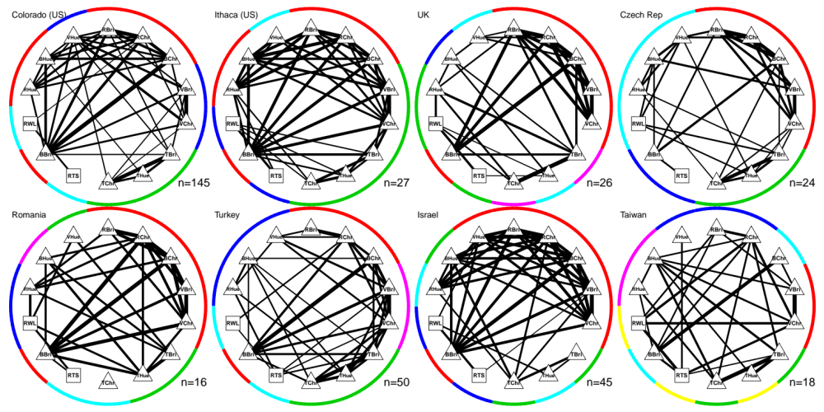

Fig 2. Same as Fig 1. But this time, only extracted and rotated factors w/ eigenvalues >=1. Ranged from 4 to 6.

Next, What if we gray out edges that are shared across all networks?

